# **JMS Virtualization**

## **Pre requisites for virtualization of JMS Topic and Queue**

Please follow the below mentioned pre requisites for working with JMS Topic and Queues in CA Devtest:

* Make sure you have demo server installed (If not then you need to install it again if you want to use the available Topic and Queues of the Demo Server).
* Run the demo server.
* Then open the link http://<hostname>:8080 in any of the browser. You will be able to see the JBoss Application page.
* In the left side of the page we have a link named – JMX console.
* Click on it and you will be directed to next page where you can see the available Topic’s and Queues of the demo server.
* You can use these Topic and Queues for JMS virtualization in your CA Devtest tool.
* Here we can create our own Topic and Queues by making the following change in the mentioned file - *DevTest\DemoServer\lisa-demo-server\jboss\server\default\deploy\jms\****jbossmq-destinations-service***
* If you don’t want to use the Demo Server Topic and Queue, then make sure that you have a JMS server where the Topic and Queues are pre created and connection details are available beforehand.

## **How to setup connection for JMS in Devtest tool?**

Follow the below steps to make the connection with the JMS Topic and Queues of Demo Server from the tool Devtest

* Create a New project Devtest.
* Go to Configs 🡪 projects 🡪 Assets and select as shown in the below figure.

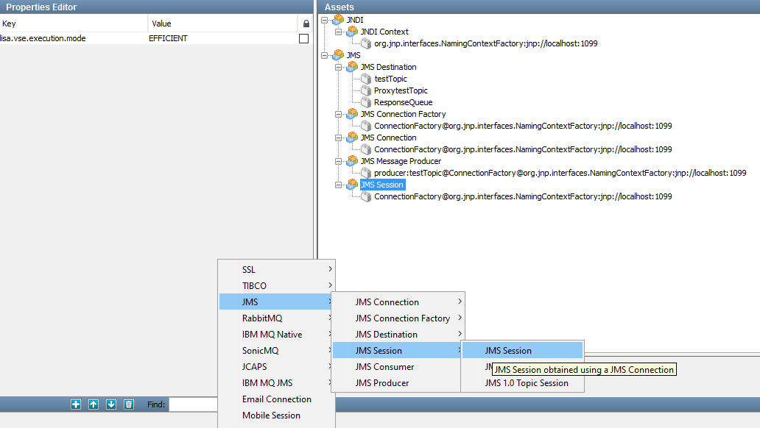

* Click on the  sign in the Assets pane and hover over – JMS 🡪 JMS Session 🡪 JMS Session
* On clicking JMS Session, the below window appears –

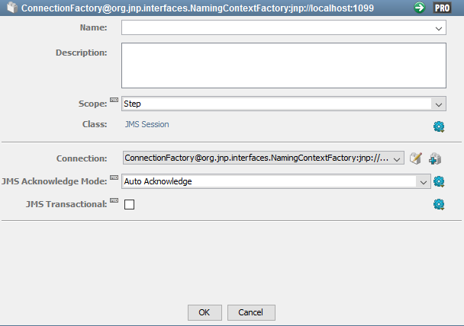

* Now the key challenge is to make the connection string by connecting various links. So that the connection is successfully established.
* Click on the  sign .
* You will be redirected to another window.
* Repeat the process till you don’t find any sign .
* On the window which is shown below give the following details as shown in figure-

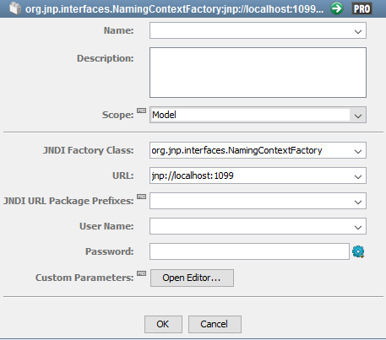

* Then click on the OK button.
* Then fill as shown on below figure –

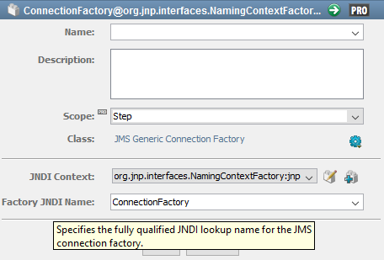

* Select the Class as – JMS Generic Connection Factory
* Then Click OK Button
* Then select Class as – JMS Connection

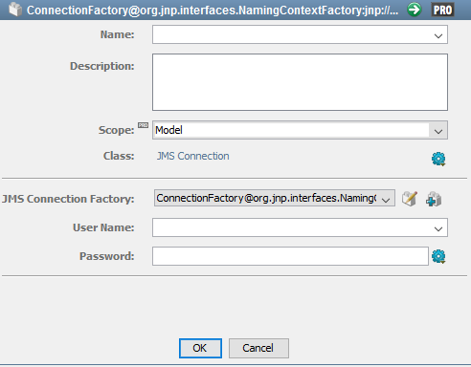

* Then click OK button
* Then click on the  sign which appears on the below figure to test whether the connection is successfully getting established or not.

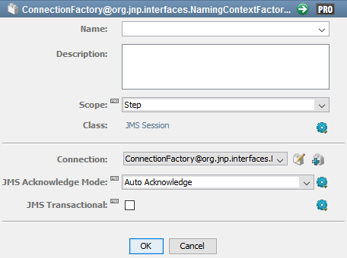

* When connection is successfully established you will get below message as shown in figure below –

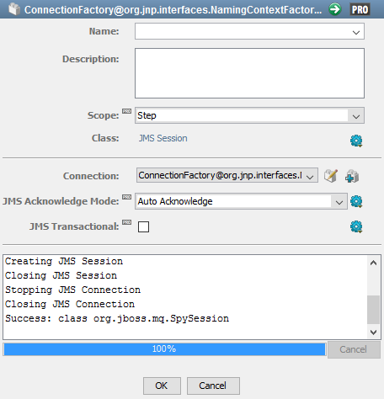

* If you do not get above message as ‘Success’ or if it shows any error, then it possibly means you are making some error while making connection string somewhere.

## **How to connect with JMS Topic and Queues**

* Once we have established the connection with the JMS Server.
* The next thing is to connect the required JMS Topic and JMS Queue.
* We can connect to the JMS Topic and JMS Queue as shown in the following figure.
* Go to Configs 🡪 projects 🡪 Assets and select as shown in the below figure.

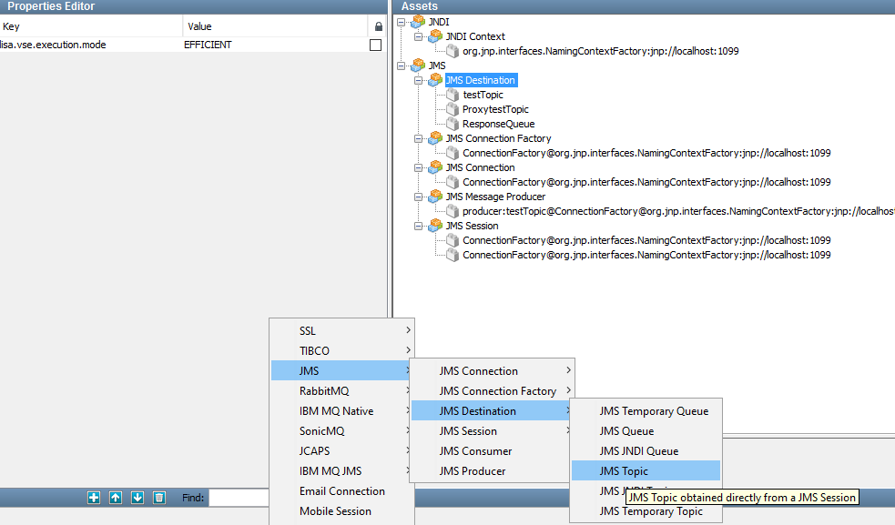

* You can select any of the options which you want or required i.e. Topic or Queue
* Once you have selected for example – JMS Topic
* The following window appears –

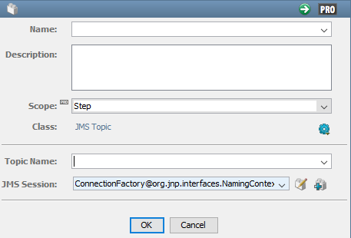

* Provide name of the Topic which you want to make connection in the text box next to Topic Name
* As well as you can test whether you are available to established connection to that particular Topic or by clicking on  button

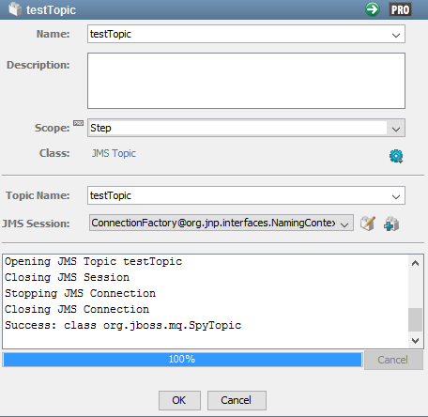

## **Creation of virtual assets using CA Devtest**

Follow the below steps for recording using JMS protocol in CA Devtest

* Setting up of the recorder by clicking  button.
* Select the protocol as JMS

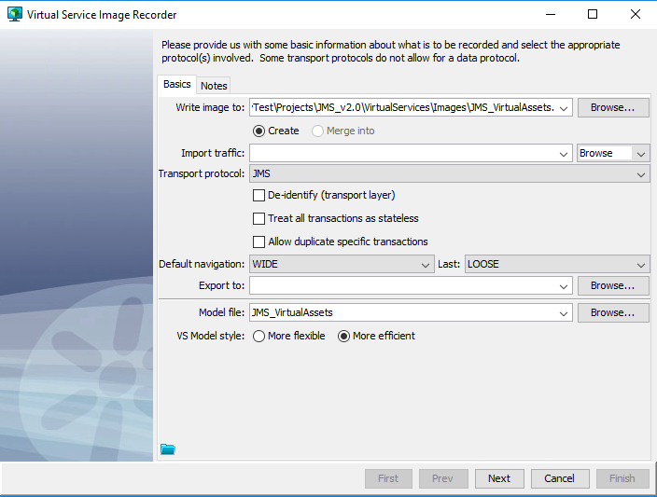

* Click on the Next button

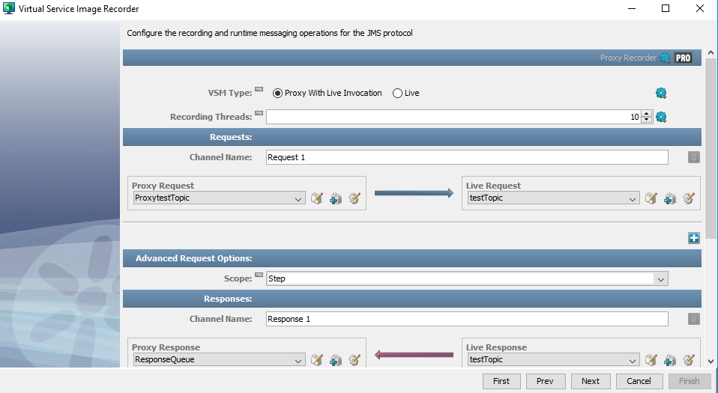

* Select the appropriate Queue/Topics from the drop down list.
* Send some request to the proxy request Queue/Topic

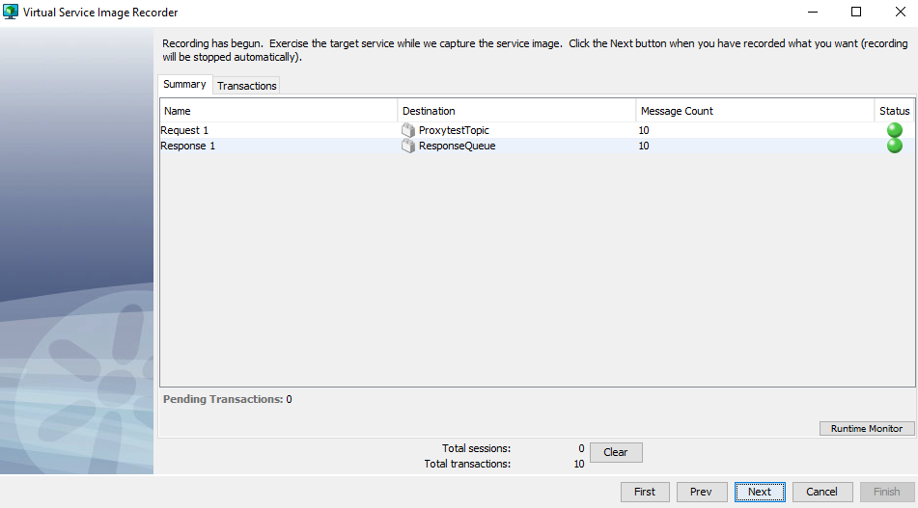

* Then click on the Next button.
* Select the appropriate Data protocol.
* Click on the Next button
* At last click the Finish button
* The virtual assets will be created.